

**OBJECT ORIENTED VISUAL PROGRAMMING**

**Final Project Report**

**Laundry Management System**

**By :**

**Almendo Gabriel Tetelepta**

**001202200002**[**Github**](https://github.com/MysteryCRB/oovpfinal_)

**PRESIDENT UNIVERSITY**

**2023**

# **DESCRIPTION**

The Laundry Management System is a Java application designed to streamline and automate laundry business operations. It offers a range of features, including customer tracking and an easy-to-use kg-to-prices calculator. With the customer tracking feature, the system allows you to efficiently manage customer information, such as their names, contact details, and address. This ensures that you have accurate records and can provide personalized service to your customers

The kg-to-prices calculator simplifies the pricing process by automatically converting the weight of the laundry into corresponding prices. This eliminates the need for manual calculations and reduces the chances of errors. It saves time for both the staff and the customers, ensuring a smooth and efficient transaction process. Overall, the Laundry Management System enhances the productivity and accuracy of your laundry business by providing a user-friendly interface for customer tracking and a convenient kg-to-prices calculator.

# **TABLE OF CONTENT**

**DESCRIPTION 2**

**TABLE OF CONTENT 3**

**I. Problem Statement 4**

1. The Problem and The Proposed Solution. 4

2. Why the Solution fixes the problem and How it will be implemented. 4

**II. Application Description 5**

1. What does LMS do? 5

2. What problem does LMS solve? 5

3. Uniqueness of LMS 5

4. Why should people use LMS? 5

**III. Implementation of OOP 6**

1. Class and Object 6

2. Inheritance 7

3. Encapsulation 8

**IV. User Interface Design 10**

1. Login Page 10

2. Homepage 11

3. Admin Page. 13

4. Customers Page 16

5. Transaksi Cucian……………………………………………………………17

6. Laporan Transaksi………………………………………………………..…20

**REFERENCES 21**

# **Problem Statement**

## **The Problem and The Proposed Solution.**

Nowadays, most people want to start a business that is simple, effective, non-seasonal and capable of generating profits. They decided to make a Laundry Business instead, because it’s non-seasonal, simple, and effective, because they think that their customers have dirty laundry piling up, with no time to do their own laundry, but the problem is, most of the people who wants to start a laundry business is still doing their business manually, by means they’re still writing customers name on paper, and do all the transaction progress manually.

## **Why the Solution fixes the problem and How it will be implemented.**

a. Automated Order Processing: The Laundry Management System will enable fast and efficient order processing, reducing waiting times and improving customer satisfaction. Admins will be able to make their customers information easily.

b. Customer Management: The Laundry Management System will centralize customer information and provide a database for storing customer profiles, preferences, and order history. This will make it easier for the Admin and the Customers

c. User-Friendly Interface: The Laundry Management System will have an intuitive and user-friendly interface, making it easy for staff members to navigate and use the system effectively. It will incorporate clear workflows, well-organized menus, and visual cues to guide users through different tasks. Training and support will be provided to ensure a smooth transition to the new system.

The implementation of the Laundry Management System will involve developing the software application using Java programming language and leveraging relevant frameworks and libraries. The system will be designed to be modular and scalable, allowing for future enhancements and integration with other systems if needed. Extensive testing and quality assurance processes will be implemented to ensure the system's reliability, security, and performance. Training sessions and documentation will be provided to assist laundry businesses in adopting and effectively utilizing the system to streamline their operations.

# **II. Application Description**

## **What does LMS do?**

Laundry Management System allows laundry business owner to make their business easier, the application can store customer’s information, such as their names, contact information, address, and how many KGs their clothes will be.

## **What problem does LMS solve?**

Laundry Management System solves small laundry businesses to improve their work, with an easy-to-use application to store their customers information and calculate the prices

## **Uniqueness of LMS**

The Simplicity of LMS is unique in that the developer have a very simple way to set-up and no internet connection needed for the admin.

## **Why should people use LMS?**

Small laundry businesses should consider using the Laundry Management Application to simplify their operations and enhance efficiency. By utilizing this application, they can streamline customer tracking and management, allowing for easy access to customer information and preferences. Additionally, the app's kg-to-prices calculator eliminates the need for manual calculations, saving time and reducing errors. With its user-friendly interface and automated features, the Laundry Management Application offers a convenient and efficient solution for small laundry businesses, enabling them to focus on providing excellent service while optimizing their workflow.

# **III. Implementation of OOP**

## **Class and Object**

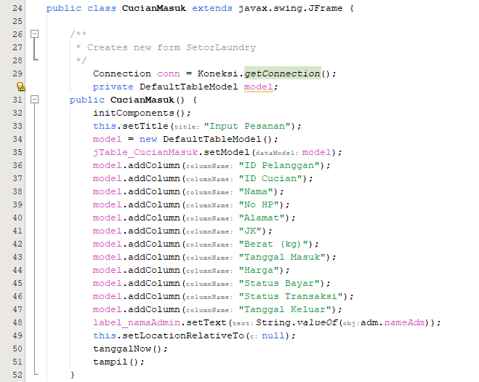

The given code represents a Java class named "CucianMasuk" that extends the "javax.swing.JFrame" class. It is a user interface class for inputting laundry orders. In object-oriented programming, a class is a blueprint for creating objects (instances) that have common attributes and behaviors. In this case, the "CucianMasuk" class represents a window or frame for entering laundry orders in a laundry management system.

The code initializes various components and sets up the user interface, such as creating a table model, setting column names for the table, and adding the model to a jTable component. It also sets the title of the window, sets the location, and calls methods like "tanggalNow()" and "tampil()" for some specific functionality. The class has a connection object, "conn", to establish a database connection using the "Koneksi.getConnection()" method from another class. It also has a label component, "label_namaAdmin", which is used to display the name of the administrator.

Overall, this class represents the graphical user interface (GUI) for entering laundry orders and has various components and functionality to support the task, he object is an instance of the class CucianMasuk, which is a subclass of javax.swing.JFrame.

## **Inheritance**

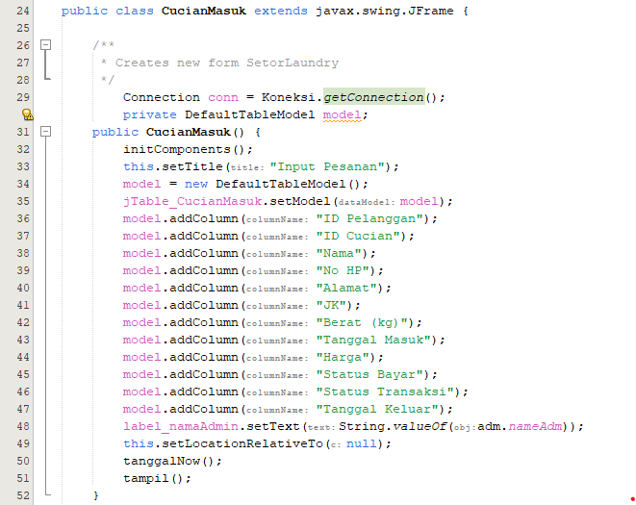

The class CucianMasuk extends the class javax.swing.JFrame. This means that CucianMasuk inherits all the properties and behaviors of the JFrame class, and it can also add its own additional properties and behaviors.

By extending JFrame, CucianMasuk class inherits features such as window management, event handling, and GUI components from JFrame. It allows to create a graphical user interface (GUI) window for inputting laundry orders (CucianMasuk) by leveraging the functionalities provided by JFrame.

In summary, inheritance in this context allows CucianMasuk to reuse and extend the functionality of the JFrame class, making it easier to create the desired user interface for your laundry management application.

## **Encapsulation**

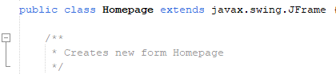

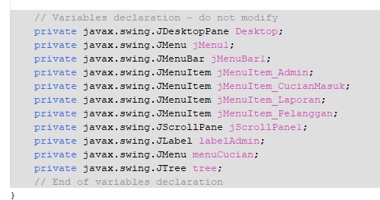

Encapsulation is a fundamental principle of object-oriented programming that involves bundling related data and methods into a single unit called a class. It helps to achieve data hiding and protects the internal state of an object from being directly accessed or modified by external code. In the code snippet provided, encapsulation is present in the class Homepage. Here's an example of how encapsulation is implemented in the code:

public class Homepage extends javax.swing.JFrame {

private javax.swing.JDesktopPane Desktop;

private javax.swing.JMenu jMenu1;

private javax.swing.JMenuBar jMenuBar1;

private javax.swing.JMenuItem jMenuItem_Admin;

private javax.swing.JMenuItem jMenuItem_CucianMasuk;

private javax.swing.JMenuItem jMenuItem_Laporan;

private javax.swing.JMenuItem jMenuItem_Pelanggan;

private javax.swing.JScrollPane jScrollPane1;

private javax.swing.JLabel labelAdmin;

private javax.swing.JMenu menuCucian;

private javax.swing.JTree tree;

// ... rest of the code ...

}

In this code, the class Homepage encapsulates various components of a graphical user interface (GUI), such as Desktop, jMenu1, jMenuBar1, jMenuItem_Admin, and so on. These variables are declared as private, which means they can only be accessed or modified within the Homepage class itself. This protects the internal state of the object and prevents external code from directly manipulating these variables. Encapsulation also allows for the inclusion of methods and logic that operate on the encapsulated data. For example, you can define methods within the Homepage class to handle events, initialize the GUI components, and perform other operations.

In summary, encapsulation in this code ensures that the internal components and state of the Homepage class are properly encapsulated and not directly accessible from outside the class, promoting information hiding and maintaining the integrity of the object's data and behaviour.

# **IV. User Interface Design**

**1. Login Page**

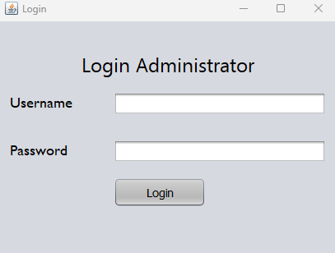

This is how the Login Page should look like, it says “Login Administrator” which means that only a certain account can access the application, which is good for business owner to access only. There are also some login form an Admin need to input, they have to input the username and password, and once they’ve done that, they click the “Login” button, and now they can access the application and it will be direct to Homepage view.

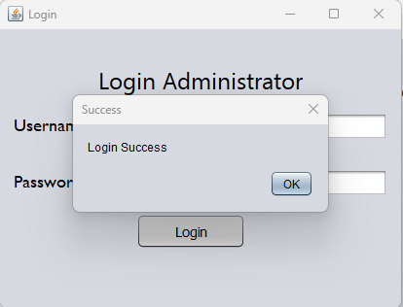

**2. Homepage**

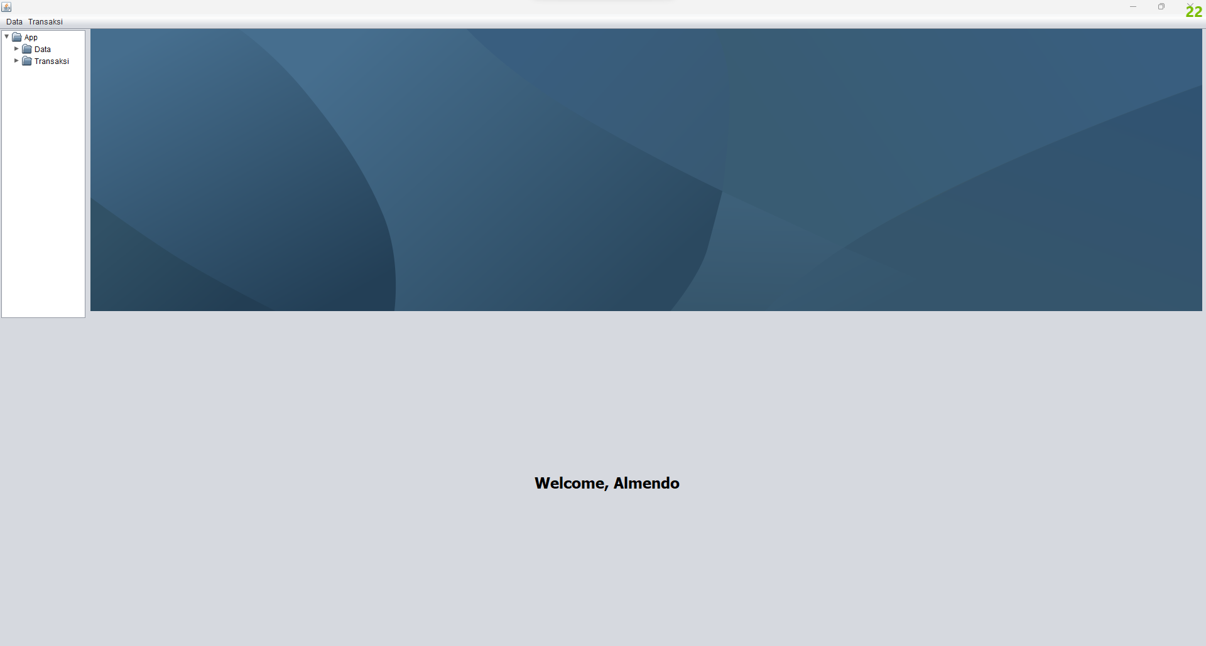

This is the Homepage, as you can see, once the Admin logged in, there’s a message that says “Welcome, Almendo”, which is a message to greet and show the Admin’s name.

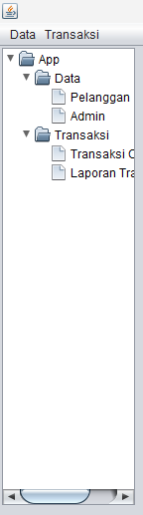

There is also this, 2 Menus at the top right, and a dropdown lists which we usually call (Tree). Let’s say you clicked Data, there’s another menus that says “Pelanggan” and “Admin”, if you clicked on “Pelanggan”, it will have a pop a new window, the mechanic is the same as “admin” and the “Transaksi” menu aswell.

**3. Admin Page**

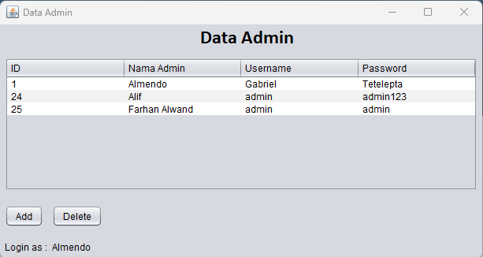

This is the Admin page, this is where you can create or delete another admin account, this is important because this is how to can access the application. There are 2 buttons on bottom left corner, which is “Add” and “Delete”.

**Add  
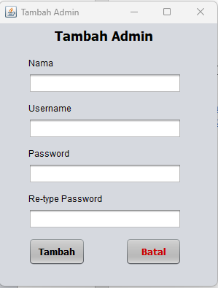**

If you clicked the “Add” button, you can create another admin to access the application, you can input Name (Display Name), Username, Password, and confirm password. There are also 2 buttons, “Tambah” is to add/create the admin, “Batal” is to cancel the new admin’s account creation

**Delete  
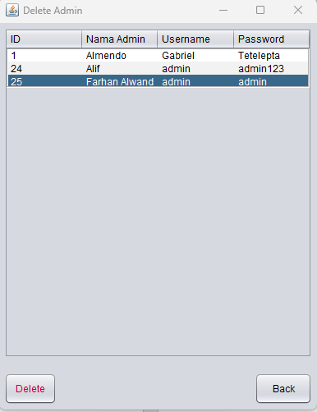**

In here, we can delete an admin account that has been created, just select one of the account, and click “Delete” button, or if you want to cancel, just click “Back” to go back to the admin page

**4. Pelanggan (Customer) Page**

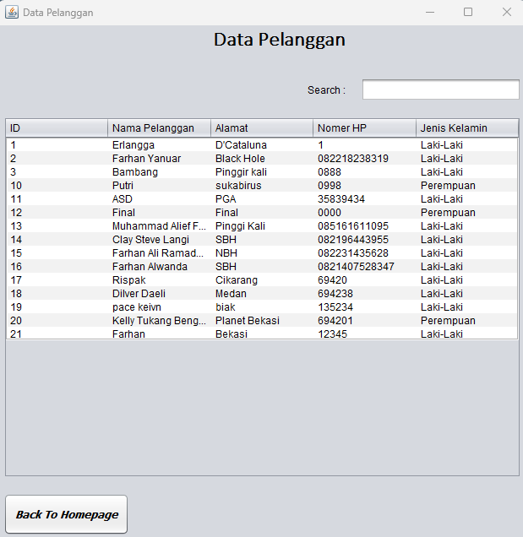

This is the “Pelanggan” page, in this page, we can check every single customer’s info, from their Transaction ID, Names, Address, Phone Number, and the Gender, this is useful for the admin to track the business progress. There’s also a search bar to search a certain customer, and a Button to go back to the Homepage

**5. Transaksi Cucian Page**

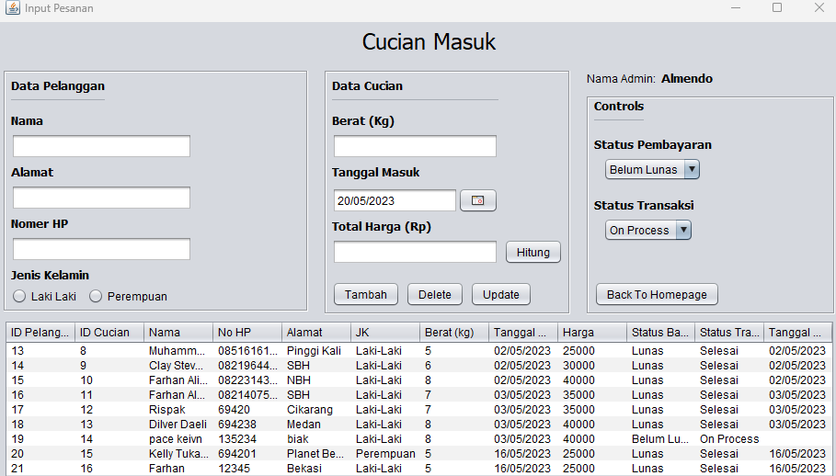

This is the main feature of the application, here you can input new customer’s info, the laundry management (the laundry weight, when did the customer bring their laundry, and calculating the price according to the weight (1kg = 5000), and the status (if the customer brought the laundry, but decided to pay tomorrow, we can set their transaction to “Belum Lunas (Not Paid)”, but if they already paid, we can set it to “Lunas (Paid)”, “Status Transaksi” is to explain the progress of the customer’s laundry, it means whether we have finished with the laundry or not.

Once we’ve input customer’s info, their laundry info, and the status, we can click “Tambah(Add)”, but let’s say the customer will pay tomorrow, and once the customer do the payment, we can set the Status to “Paid” and we can click “Update”, we can also delete the info by clicking “Delete”

Here’s the example:

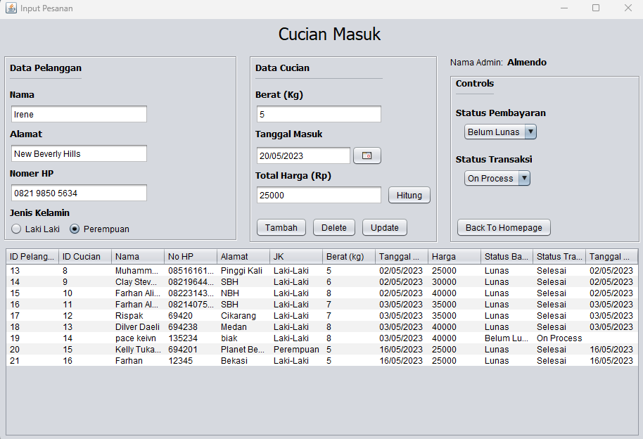

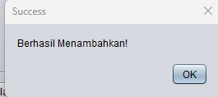

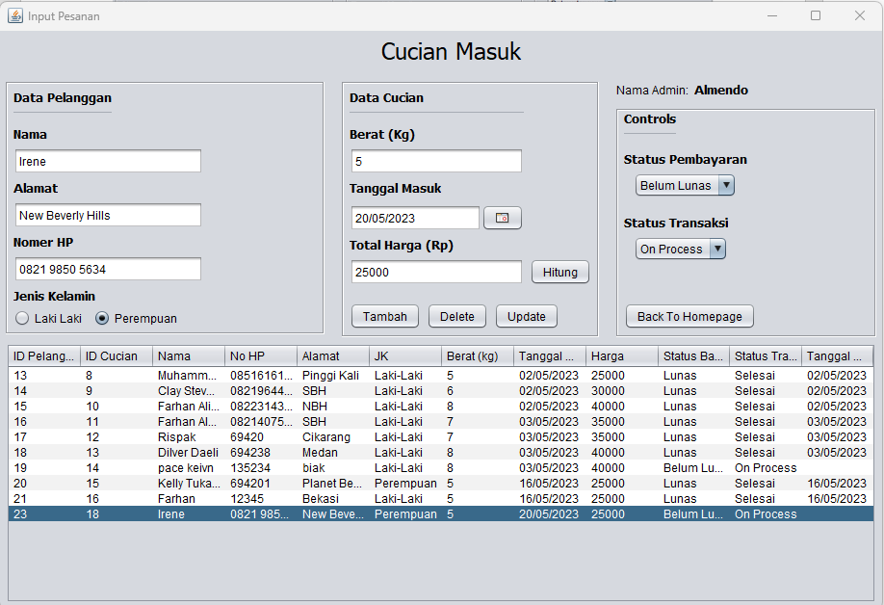

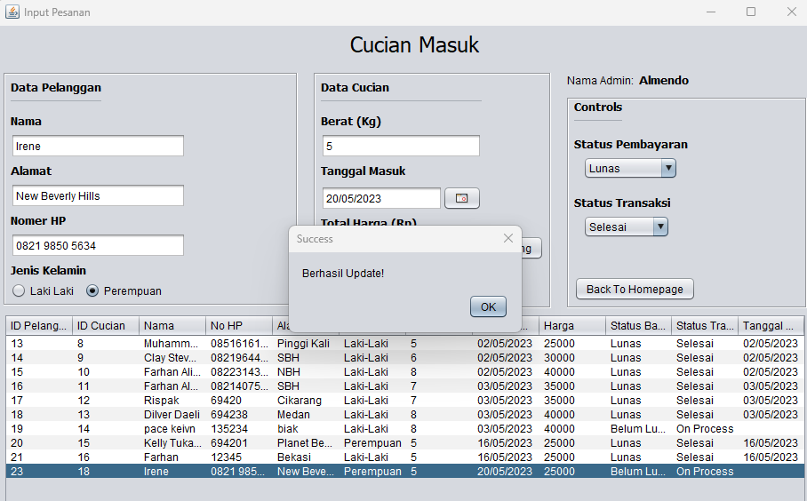

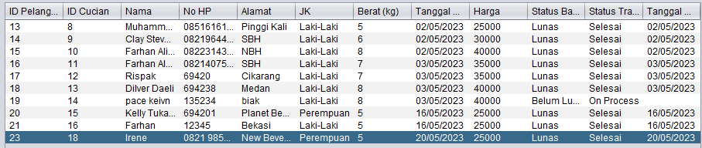

**6. Laporan Transaksi Page**

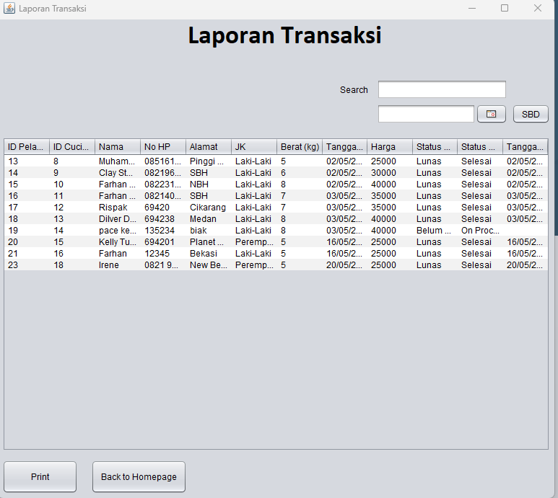

This is the “Report” page, we can see all the transaction made in this page, this page is similar to “logs”. There’s a search bar to search a certain customer, and 2 buttons at the bottom, “Print” is to print the receipt, and “Back to Homepage” is to go back to the Homepage.

# **REFERENCES**

1. <https://netbeans.apache.org/kb/docs/java/>

2. <https://docs.oracle.com/javase/tutorial/>